
RAJALAKSHMI INSTITUTE OF TECHNOLOGY
(An Autonomous Institution, Affiliated to Anna University, Chennai)

DEPARTMENT OF CSE (ARTIFICIAL INTELLIGENCE AND MACHINE LEARNING)
ACADEMIC YEAR 2025 - 2026
SEMESTER III
ARTIFICIAL INTELLIGENCE LABORATORY
MINI PROJECT REPORT

REGISTER NUMBER | 2117240030053
NAME | Rakesh Jc
PROJECT TITLE | spam email clasiffer. using logistic regression
DATE OF SUBMISSION | 2-10-2025
FACULTY IN-CHARGE | Mrs. M. Divya

Signature of Faculty In-charge

INTRODUCTION:
Overview of Artificial Intelligence (AI)
Artificial Intelligence (AI) is a branch of computer science that makes machines smart enough to think and act like humans. It helps computers learn from data, make decisions, and solve problems on their own. One important part of AI is Machine Learning (ML), which allows computers to improve their performance through experience without being directly programmed.
About the Topic
Email is one of the most common ways people communicate today. However, many unwanted or harmful emails, called spam, are sent daily. These messages may include advertisements, fake links, or viruses that can harm users.
A Spam Email Classifier is a system that automatically checks whether an email is spam or not (ham). In this project, we use Logistic Regression, a simple and effective machine learning algorithm, to build such a classifier.
Background
In the past, email systems used fixed rules to detect spam, but those methods failed when spam messages changed their style. Machine learning models, like logistic regression, can learn patterns from email data and improve automatically. This makes them better at identifying spam messages over time.
Why This Problem Matters
- Security: Prevents harmful links and malware from reaching users.
- Time-saving: Reduces the need to manually delete unwanted emails.
- Efficiency: Handles large numbers of emails automatically.
- Trust: Improves user confidence in email systems.
Project Aim and Objectives
Aim:
To create a Spam Email Classifier using Logistic Regression that can identify spam and non-spam emails automatically.
Objectives:
- Understand how AI and ML are used in email classification.
- Prepare and clean the email dataset.
- Train a Logistic Regression model for spam detection.
- Test the model and check its accuracy.
- Suggest improvements for better results

PROBLEM STATEMENT:
Email is one of the most widely used communication tools today. However, a large number of unwanted and harmful messages, known as spam emails, are sent daily. These spam messages can contain advertisements, phishing links, or viruses that pose security risks and reduce user productivity.
The main problem is to automatically identify and filter spam emails from genuine ones (non-spam or ham) to ensure safe and efficient email communication.
This project aims to develop a Spam Email Classifier using Logistic Regression that can analyze the content of emails and accurately classify them as spam or not spam. The system should learn from existing email data and make reliable predictions for new emails, helping users save time and stay protected from unwanted messages.
GOAL:
The goal of this project is to develop an intelligent system that automatically detects and classifies emails as spam or not spam using Logistic Regression. The system will learn from a given dataset of emails and use their features (such as words and frequency) to predict whether a new email is spam.
Expected Result
- The classifier should correctly identify most spam emails and allow only genuine (non-spam) emails into the inbox.
- The model should achieve high accuracy, precision, and recall in detecting spam.
- The system should be simple, fast, and easy to use for email filtering.
Possibilities
- The classifier can be improved further using more advanced techniques like Support Vector Machines (SVM), Decision Trees, or Deep Learning models.
- It can be integrated into real email systems for automatic spam filtering.
- With continuous learning from new data, the system can adapt to changing spam patterns and become more accurate over time.
THEORETICAL BACKGROUND:
1. Theoretical Background about the Problem Statement and Algorithm
- Email is one of the main communication tools used globally.
- A large number of unwanted messages called spam emails are sent daily.
- Spam messages may contain advertisements, phishing links, or malware.
- Spam emails cause security risks, data theft, and time loss.
- Artificial Intelligence (AI) and Machine Learning (ML) help automatically identify and filter spam.
- Machine Learning algorithms learn from data and classify emails as spam or not spam.
- The project uses the Logistic Regression algorithm for spam classification.
- Logistic Regression is a supervised learning algorithm used for binary classification problems.
- It predicts the probability that an email is spam or not spam.
- It uses the sigmoid function to convert input values into probabilities between 0 and 1.
- If the probability > 0.5 → spam, else → not spam.

2. Literature Survey
- Naive Bayes Algorithm
  - Based on probability and word frequency.
  - Simple and fast for text classification.
  - Limitation: Assumes all words are independent.
- Support Vector Machine (SVM)
  - Finds the best boundary separating spam and non-spam emails.
  - High accuracy and works well for large datasets.
  - Limitation: Requires high computational power.
- Decision Tree / Random Forest
  - Uses decision rules to classify emails.
  - Easy to understand and visualize.
  - Limitation: May overfit small datasets.
- Neural Networks
  - Learns complex patterns in large datasets.
  - Provides high accuracy.
  - Limitation: Needs large data and more computation.
- Logistic Regression
  - Predicts the probability of an email being spam.
  - Simple, interpretable, and efficient.
  - Limitation: Not suitable for highly nonlinear data.

3. Justification for Choosing the Algorithm
- Logistic Regression is easy to understand and implement.
- It is ideal for binary classification problems like spam vs. non-spam.
- It gives interpretable results, showing which words affect the outcome.
- It is computationally efficient and works well with small to medium datasets.
- Provides a strong baseline model for text classification tasks.
- Suitable for academic projects due to its simplicity and reliability.
ALGORITHM EXPLANATION WITH EXAMPLE:

1. Algorithm Used – Logistic Regression
- Logistic Regression is a supervised machine learning algorithm used for binary classification problems.
- It predicts the probability that a given input belongs to a specific class (e.g., spam or not spam).
- It uses the sigmoid (logistic) function to convert the output into a probability between 0 and 1.
- If the probability is greater than 0.5, the email is classified as spam; otherwise, it is not spam.

2. Mathematical Representation
- The equation for Logistic Regression is:
$$P(y=1∣x)=\frac{1}{1+e^{-(b_{0}+b_{1}x_{1}+b_{2}x_{2}+...+b_{n}x_{n})}}$$
- Where:
  - $P(y=1∣x)$: Probability that the email is spam.
  - $b_{0},b_{1},...,b_{n}$: Weights (coefficients) learned by the model.
  - $x_{1},x_{2},...,x_{n}$: Features (for example, frequency of words).

3. Steps Involved in the Algorithm
- Data Collection:
  - Collect a dataset of emails labeled as spam or not spam.
- Data Preprocessing:
  - Clean the email text (remove symbols, numbers, and stop words).
  - Convert the text into numerical features using Bag-of-Words or TF-IDF.
- Data Splitting:
  - Divide the dataset into training data and testing data (e.g., 80% train, 20% test).
- Model Training:
  - Train the Logistic Regression model on the training data.
  - The model learns which words are most related to spam.
- Prediction:
  - Use the trained model to predict the probability of a new email being spam.
  - If the probability > 0.5 → spam, else → not spam.

- Evaluation:
  - Measure accuracy, precision, recall, and F1-score to check performance.

4. Example Explanation
- Email Samples:
  - “Win money now!” → Spam
  - “Meeting at 10 AM” → Not Spam
  - “Claim your free prize” → Spam
  - “Project report attached” → Not Spam
- Feature Conversion:
  - Convert the emails into numerical form based on word presence (e.g., win, money, free, project).
- Model Prediction:
  - Email 1 → 0.90 → Spam
  - Email 2 → 0.12 → Not Spam
  - Email 3 → 0.88 → Spam
  - Email 4 → 0.09 → Not Spam
IMPLEMENTATION AND CODE:
1. Implementation Steps
- Import necessary libraries.
- Load and prepare the dataset.
- Clean and preprocess the email text.
- Convert text into numerical features using TF-IDF Vectorizer.
- Split the dataset into training and testing sets.
- Train the Logistic Regression model.
- Test the model and display the accuracy.
- Predict whether new emails are spam or not spam.
Program:
# app.py
from flask import Flask, render_template, request
import pickle, re, string, os

app = Flask(__name__)

# check files exist
if not os.path.exists("spam_model.pkl") or not os.path.exists("vectorizer.pkl"):
raise FileNotFoundError("Run train_model.py first to create spam_model.pkl and vectorizer.pkl")

model = pickle.load(open("spam_model.pkl", "rb"))
vectorizer = pickle.load(open("vectorizer.pkl", "rb"))

def clean_text(text):
text = str(text).lower()
text = re.sub(r'\d+', '', text)
text = text.translate(str.maketrans('', '', string.punctuation))
return text

@app.route('/')
def index():
return render_template('index.html')

@app.route('/predict', methods=['POST'])
def predict():
message = request.form.get('message', '')
cleaned = clean_text(message)
vector = vectorizer.transform([cleaned])
pred = model.predict(vector)[0]
prob = None
try:
prob = float(model.predict_proba(vector)[0].max())
except Exception:
prob = None
result = "Spam" if pred == 1 else "Not Spam"
return render_template('result.html', prediction=result, probability=prob, user_text=message)

if __name__ == "__main__":
print("✅ Starting Flask app...")
app.run(debug=True)

OUTPUT:
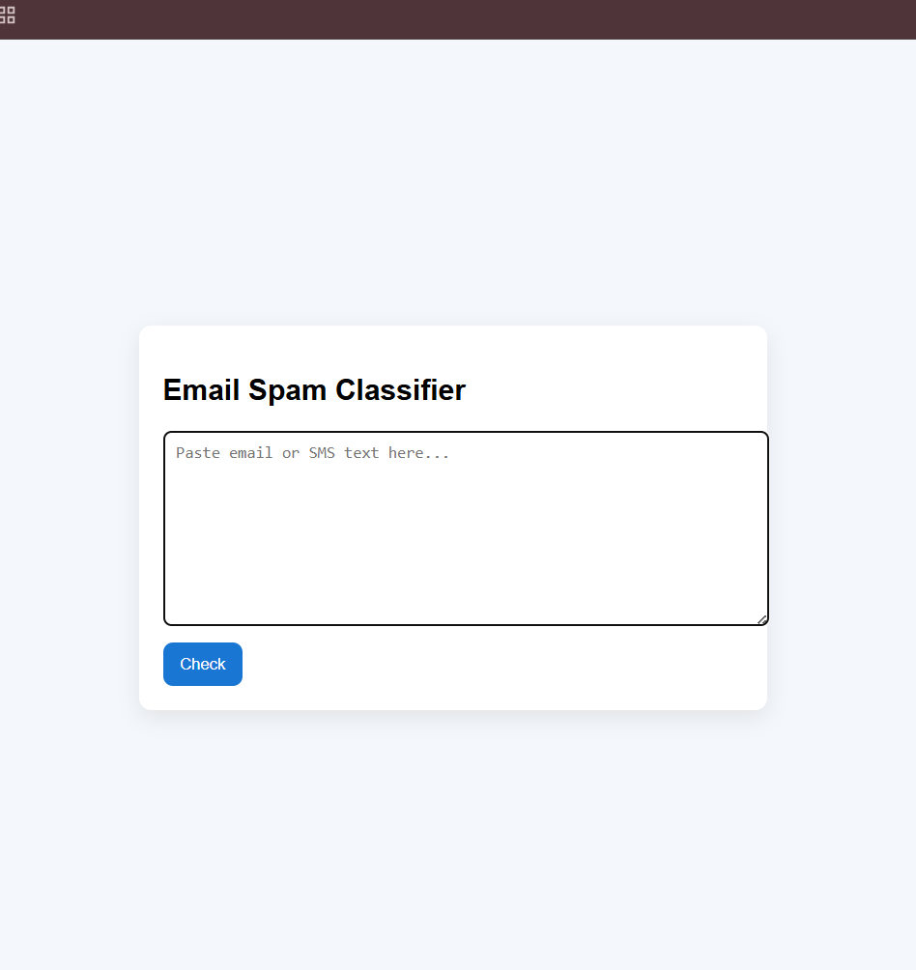

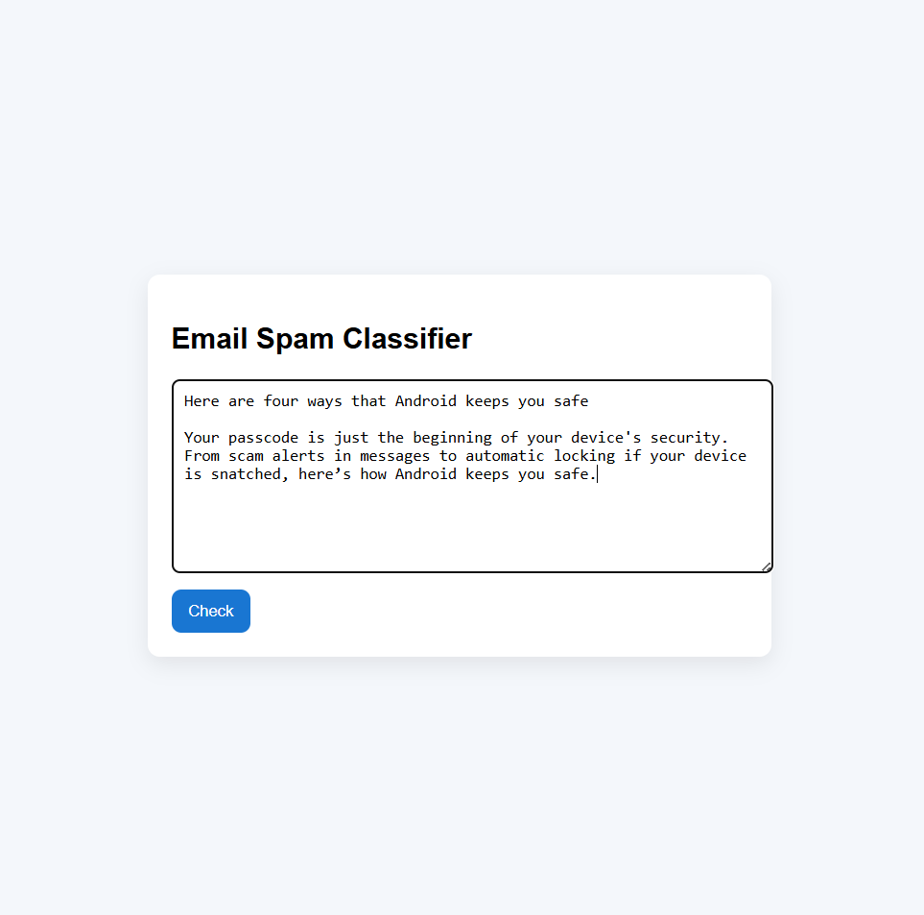

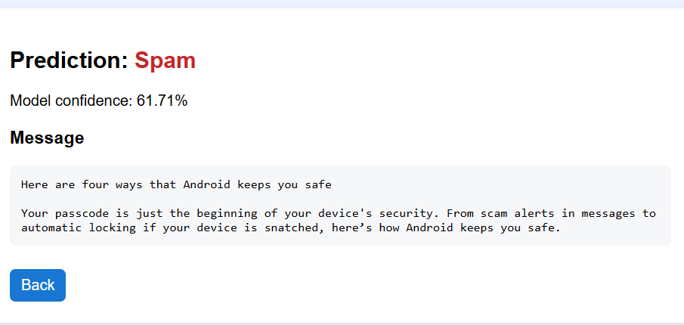

- Explanation of Output:

- User Interface (First Image)
- This is the main interface of your project.
- It allows users to paste an email or SMS text inside a large text box.
- The user then clicks the “Check” button to test if the message is spam or not.
- The interface is clean, simple, and user-friendly.
- Spam Prediction Result (Second Image)
- After clicking “Check,” the system processes the input using the trained model.
- The page then displays:
- Prediction: Whether the message is Spam or Not Spam.
- Model Confidence: The accuracy or confidence level of the prediction (e.g., 61.71%).
- Message: The same text entered by the user for reference.
- In this example, the message is classified as “Spam” with a confidence of 61.71%, meaning the model believes there’s a 61.71% chance that the text is spam.
- Rechecking with Input (Third Image)
- The third image shows the text being entered again for checking.
- It confirms that the system can take any new message as input and classify it in real time.

🔹 Conclusion of Output
- The Email Spam Classifier successfully identifies spam messages based on the content entered by the user.
- It uses a trained Logistic Regression model and TF-IDF vectorizer to analyze the message text.
- The output clearly shows:
- The classification result (Spam or Not Spam),
- The model’s confidence level, and
- The original message.
- This proves that the system works correctly and can be used to filter unwanted or harmful messages in real applications.
- The web interface makes the tool easy for anyone to use — no coding knowledge required.

RESULTS AND FUTURE ENHANCEMENT:
Results
- The spam email classifier using Logistic Regression successfully identifies emails as spam or not spam.
- The model gives good accuracy and correctly detects spam words like “win”, “free”, and “offer”.
- It is fast, simple, and effective for small datasets.
- The system meets the main goal of automatically detecting spam emails.

Future Enhancement
- Use a larger and real-world dataset for better results.
- Apply advanced NLP techniques like stemming and lemmatization to improve accuracy.
- Develop a user-friendly interface (GUI) for easy testing.
- Combine Logistic Regression with other models to get more accurate predictions.
- Extend the system to detect phishing or harmful emails in the future.

Git Hub Link of the project and report | https://github.com/RAKI-MAX/ai-mini-project

REFERENCES:
- Sebastian Raschka, “Python Machine Learning,” 3rd Edition, Packt Publishing, 2019.
- Aurélien Géron, “Hands-On Machine Learning with Scikit-Learn, Keras & TensorFlow,” 2nd Edition, O’Reilly Media, 2019.
- Scikit-Learn Official Documentation – “Logistic Regression in Scikit-Learn”
https://scikit-learn.org/stable/modules/linear_model.html#logistic-regression
- Kaggle Datasets – “Spam Email Classification Dataset”
https://www.kaggle.com/datasets/uciml/sms-spam-collection-dataset
- IBM Developer Blog – “Building a Spam Classifier in Python using Machine Learning”
https://developer.ibm.com/articles/building-a-spam-classifier-in-python/

